Functional Specification

Download Images Page

Table of Contents

1 PERMISSION CONTROL 2

2 DATA MIGRATION 2

3 landing PAGE STRUCTURE 2

3.1 HEADER 3

3.2 SEARCH BOX 3

3.3 LATEST UPLOADED IMAGES 3

3.4 HOW TO USE THE LIBRARY 3

3.5 POPULAR IMAGES SEARCHES 3

3.6 MOST POPULAR TEMPLATES 4

3.7 FEATURED CAMPAIGN SHOWCASE 4

4 SEARCH RESULT LIST PAGE STRUCTURE 5

4.1 HEADER 6

4.2 SEARCH BOX 6

4.3 SEARCH RESULT INFORMATION 6

4.4 IMAGES LIST 6

4.5 HOW TO USE THE LIBRARY AND POPULAR IMAGES SEARCHES 6

5 IMAGE DETAIL PAGE STRUCTURE 7

5.1 HEADER 8

5.2 IMAGE DETAILS INFORMATION 8

5.3 HOW TO USE THE LIBRARY AND POPULAR IMAGES SEARCHES 8

6 IMAGES MAINTAINENCE 8

# PERMISSION CONTROL

* All login users can view this page
* Only Brand team members can maintain images in backend

# DATA MIGRATION

All the images in the new site should be migrated from the Image Library of current Brand Space website

# landing PAGE STRUCTURE

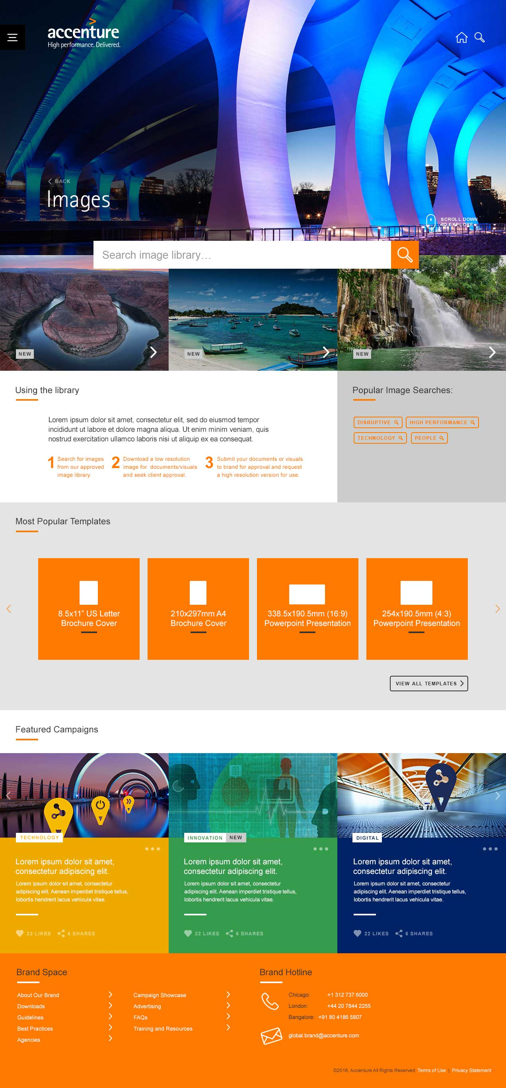

Images landing page is consist of below sections:

* Header
* Search box
* Latest Uploaded Images
* How to use the library
* Popular Images Searches
* Most Popular Templates
* Featured Campaign Showcase
* Footer

## HEADER

Follow the same style through the whole site, title text is “Images”, click the “BACK” link will take user to the Downloads landing page

## SEARCH BOX

The search box is at the horizental center of the page, the default texts in it is “Search image library…” with gray color



Once user types key word in the textbox, the font color is changed to normal black font color(#333333)



Click the search button will go to the search result page where lists all the images which meet the search keywords

## LATEST UPLOADED IMAGES

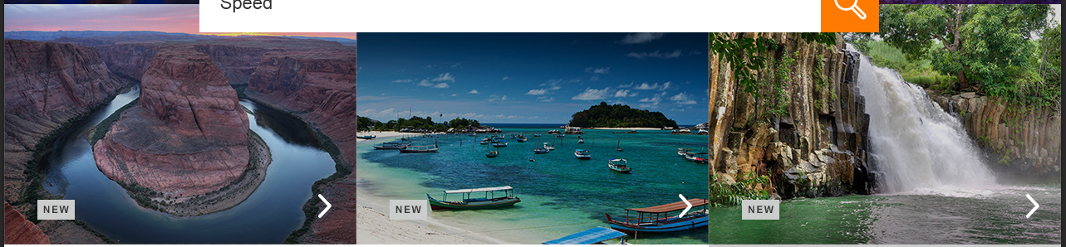

This section lists the latest 3 uploaded images, with a “NEW” label on the left bottom corner, one right arrow at right bottom corner. Each image box should be clickable so user clicks any part of the image tile will go to its detail page

## HOW TO USE THE LIBRARY

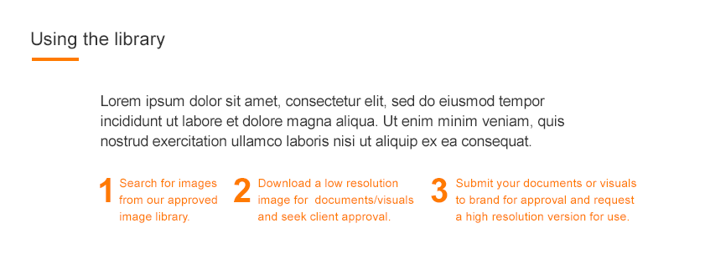

This section are a static texts which instructs users how to use the image library

## POPULAR IMAGES SEARCHES

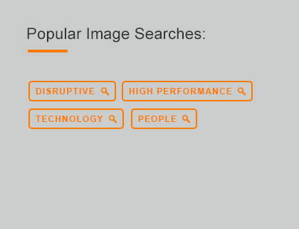

This section specified 4 popular search keywords: DISRUPTIVE, HIGH PERFORMANCE, TECHNOLOGY and PEOPLE, click each keyword button will take users to the search result page where lists all the images which meet the search keywords

## MOST POPULAR TEMPLATES

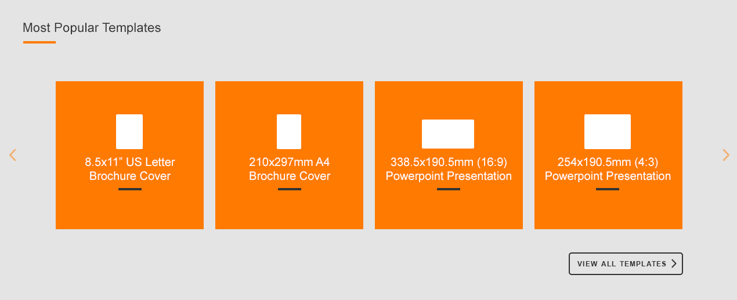

This section lists the top 12 downloaded templates as a carousel. Hover on each tile, its background color will be changed to light gray, click each tile will download the template. Click “VIEW ALL TEMPLATES” will take users to the templates landing page

## FEATURED CAMPAIGN SHOWCASE

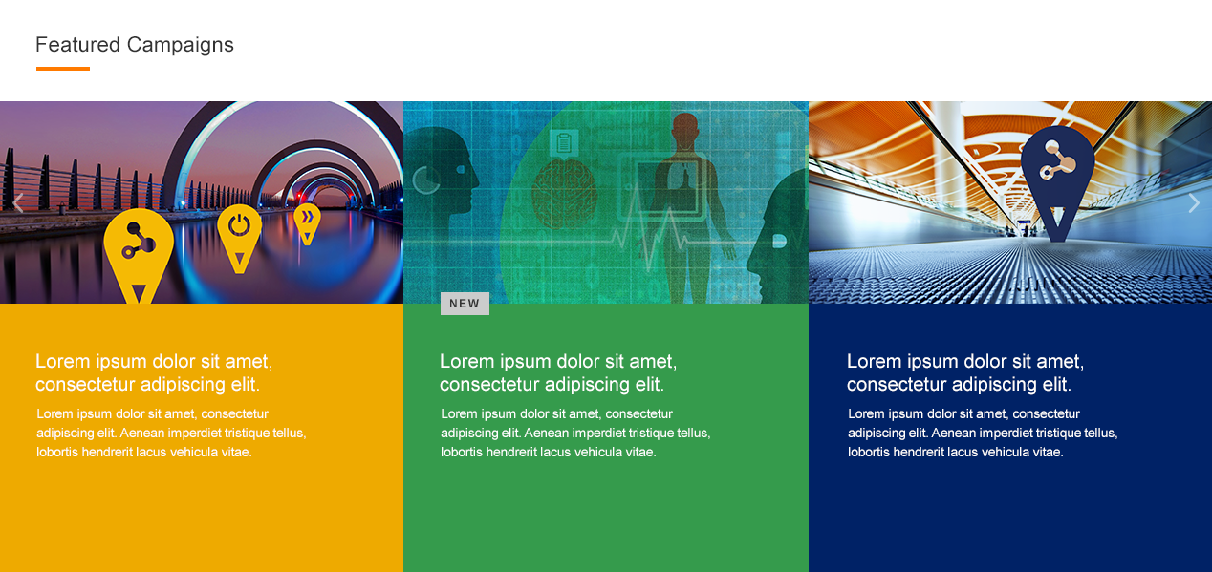

This section pulls 12 showcase randomly from the featured campaign showcase pool, and disply them as a carousel. Each showcase tile is consist of below elements:

* The hero image thumbnail on the top
* The showcase title and description with white color font, and its backgrnd showcase’s primary color
* If the showcase was approved in rencent two weeks, then there will be a “NEW” label

Hover the showcase tile the background color will be changed to white and font color will be changed to black(#333333).

# SEARCH RESULT LIST PAGE STRUCTURE

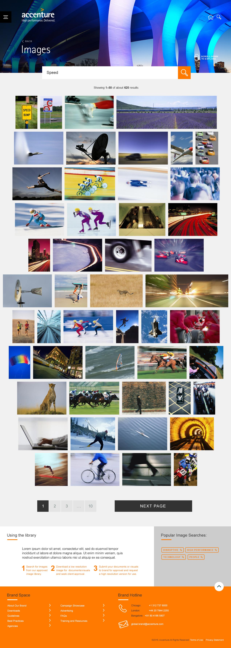

Images search result page is consist of below sections:

* Header
* Search box
* Search result information
* Images list
* How to use the library
* Popular images searches
* Footer

## HEADER

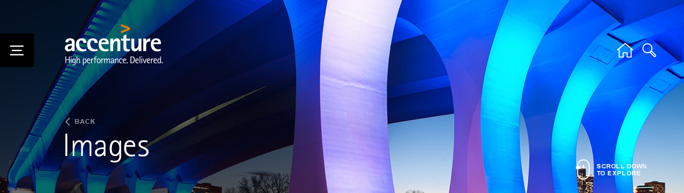

Follow the same style through the whole site, title text is “Images”, click the “BACK” link will take user to the Images landing page

## SEARCH BOX



The searched keyword will be pre-populated into the search box in the result page, and users can change the keyword and by clicking the search button to start a new search.

## SEARCH RESULT INFORMATION

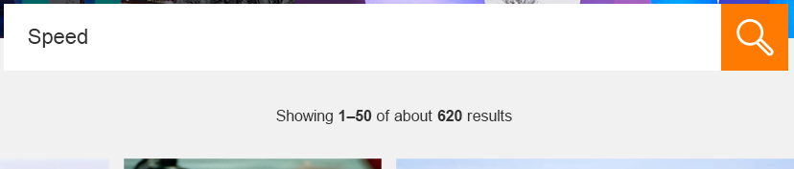

Between the search box and images list, there is search result information, which includes images numbers in current page, total number of images returned.

## IMAGES LIST

The images list lists all the images which include the searched key word in below fields:

* Image title
* Orientation
* Description
* Capability
* Project name
* Sponsor name
* Photographer/Supplier
* Unique Item ID
* Sponsor Organization
* Photography Category
* Usage Restrictions

All the images are listed order by the uploaded date, newly uploaded ones are in the first place.

It displays 60 images per page, and there is the pagination under the images list which allows users go to different page of the search result.

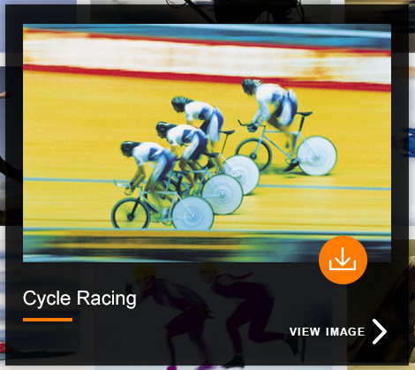

When hover one image thumbnail, one popup window will be shown which includes:

* A middle size of the image
* Image’s title
* A download link which will open the original size image in a new window
* A link “VIEW IMAGE” which will take users to the image detail page

When move out the popup panel, the panel will be disappear

## HOW TO USE THE LIBRARY AND POPULAR IMAGES SEARCHES

These two parts functions are the same as images landing page

# IMAGE DETAIL PAGE STRUCTURE

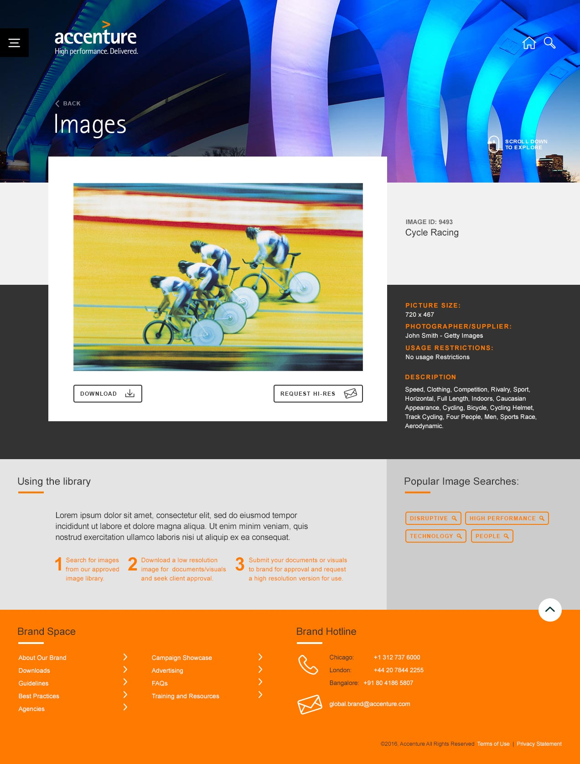

Images detail page is consit of below sections:

* Header
* Image details information
* How to use the library
* Popular images searches
* Footer

## HEADER



Follow the same style through the whole site, title text is “Images”, click the “BACK” link will take user to the Images search result page and previous search result will be displayed

## IMAGE DETAILS INFORMATION

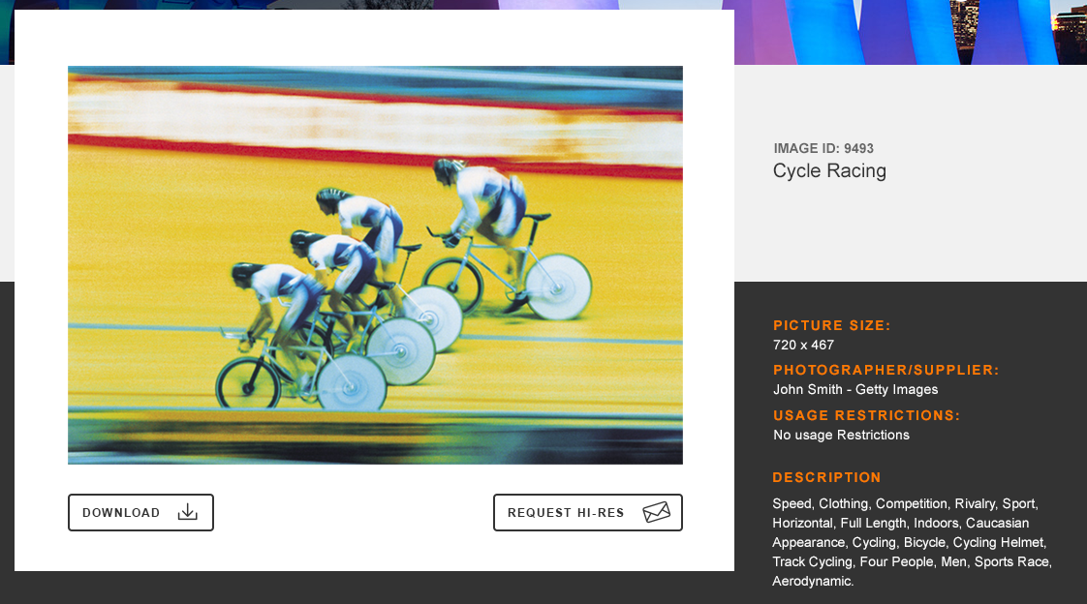

This section includes below parts:

* A middle size of the image
* A DOWNLOAD button, click it will open the original size image in a new window
* A “REQUEST HI-RES” button, click it will open an new email, “Send To” of the email is [brandspace@accenture.com](mailto:brandspace@accenture.com)
* IMAGE details information which includes: IMAGE ID(unique item id), image title. For other image fields, if the field has value, then it will be shown in this detail section, if there is no value for the field, then it will not be shown

## HOW TO USE THE LIBRARY AND POPULAR IMAGES SEARCHES

These two parts functions are the same as images landing page

# IMAGES MAINTAINENCE

Brand team can add/edit/delete any images in the backend